1. Enter 5 Digit Phone Number, It gives the below invalid error, which is correct.

NOTE:- Indian Valid Phone Number should be +91 - 9999900000 (Country Code - 10 digit Phone Number)

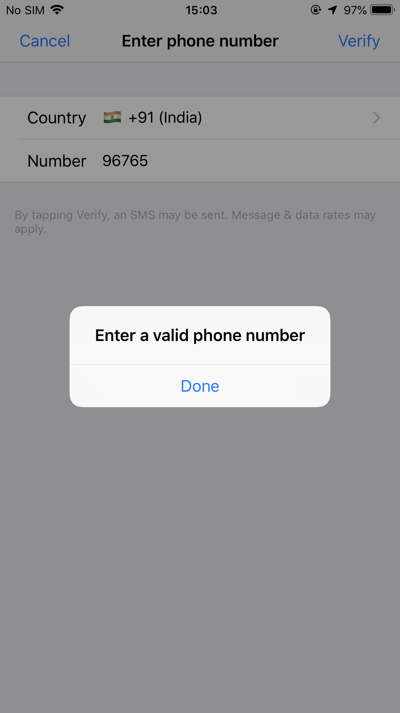

2) If the phone number exceeds 5 digits verification is allowed and moves to next screen (Passcode screen)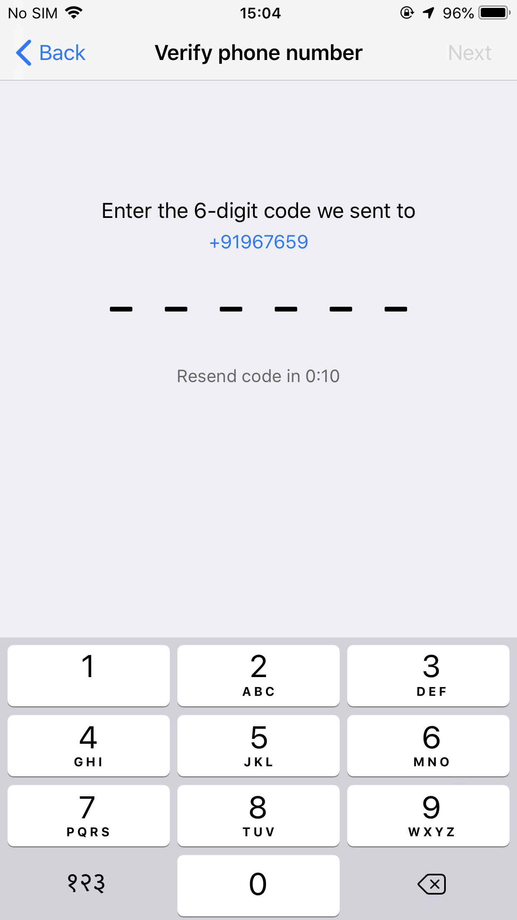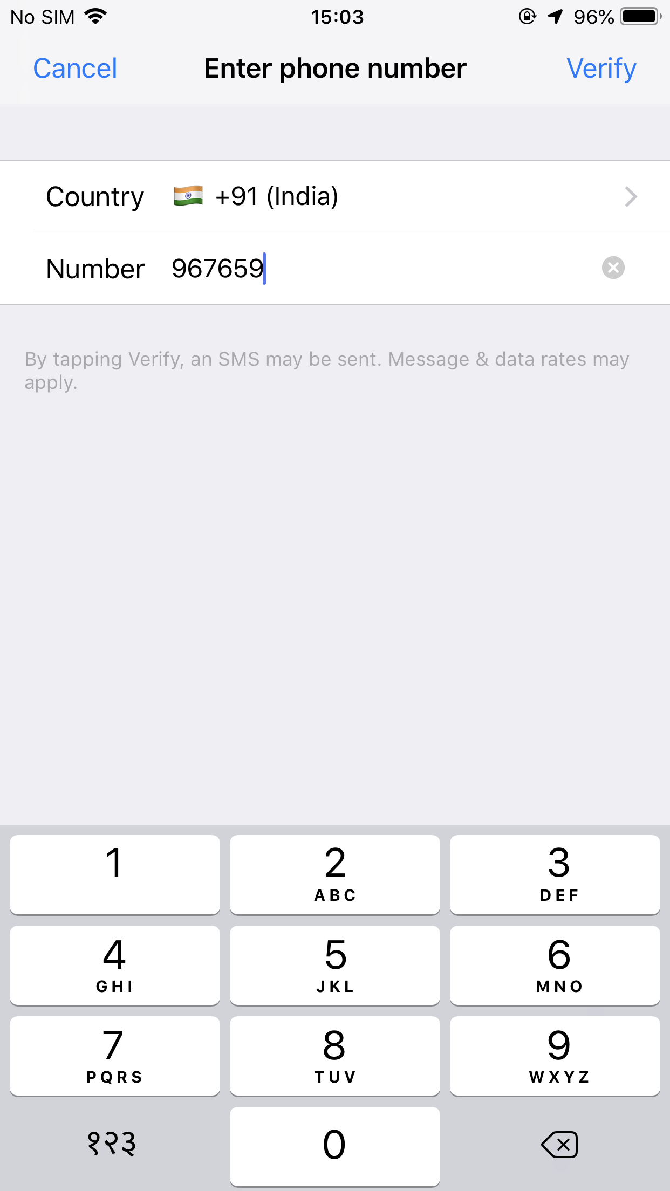

3) Once the passcode is entered, then it says wrong passcode.

Validation should be like If the Phone Number entered is **not 10 digits** it should throw an error in Step 2 itself on tap of verify button. Instead its navigating to passcode screen and says wrong code.